

**Formula Hybrid ESF -- Part 1**

**INTRODUCTION**

Part 1 of the Formula Hybrid ESF is intended to help teams solidify those design decisions that need to be made early in the program. This will also help the technical reviewers identify possible areas of concern early.

Many of the fields in this form will also be found in the ESF Part 2 and the information in those fields will need to be reentered when the ESF Part 2 is submitted.

It is expected that some of the information will change during the development of the vehicle. Teams should not feel “locked in” by the data provided here, however data entered in the ESF Part 2 will be considered final.

The information in this form will also be provided to the design judges, so teams may expect questions during the design event relating to why a particular aspect of the vehicle was changed during development.

**INSTRUCTIONS AND REQUIREMENTS**

.

1. Enter the information requested as accurately as possible. If a particular portion of the design has not been finalized, give a short description of the options being considered.
2. Please submit any questions, corrections and suggestions for improvement to:

<http://www.formula-hybrid.org/level2/support/index.php>

1. When completed, this document must be converted to a pdf and submitted to:

<http://formula-hybrid.com/uploads/>

**Table of Contents**

Section 1 Vehicle Overview 2

Section 2 Frame and Body 3

Section 3 Engine 4

3.1 Engine Data 4

3.2 Architecture 4

Section 4 Electrical System Overview 5

4.1 Block Diagram 5

4.2 Vehicle Layout 5

4.3 Electrical System Parameters 6

4.4 Firewall(s) 6

Section 5 Tractive System 7

5.1 Motor(s) 7

5.2 Motor Controller 7

Section 6 Accumulator System 8

6.1 Accumulator Pack 8

6.2 Cell Description 8

6.3 Cell Configuration 9

6.4 Lithium-Ion Pouch Cells 9

6.5 Accumulator Management System (AMS) 9

6.6 Charging 9

6.7 Accumulator Container/Housing 10

6.8 Shutdown Circuit 10

6.9 IMD 11

Section 7 GLV System 12

7.1 GLV System Data 12

List of Figures

Figure 1- Electrical System Block Diagram 5

Figure 2 - Locations of major TS components 5

Figure 3 – Safety Shutdown Circuit Schematic 11

*Must be hyperlinked!*

List of Tables

Table 1 - Engine Data 4

Table 2 - General Electrical System Parameters 6

Table 3 - Motor Specifications 7

Table 4 - Motor Controller Specifications 7

Table 5 - Main Accumulator Parameters 8

Table 6 - Main Cell Specification 8

Table 7 - AMS Data 9

Table 8 - Accumulator Charging Data 10

Table 9 - Parameters of the IMD 11

Table 10 - GLV Data 12

*Must be hyperlinked*!

# TITLE PAGE

*Please include team logo, car picture, team picture, etc..*

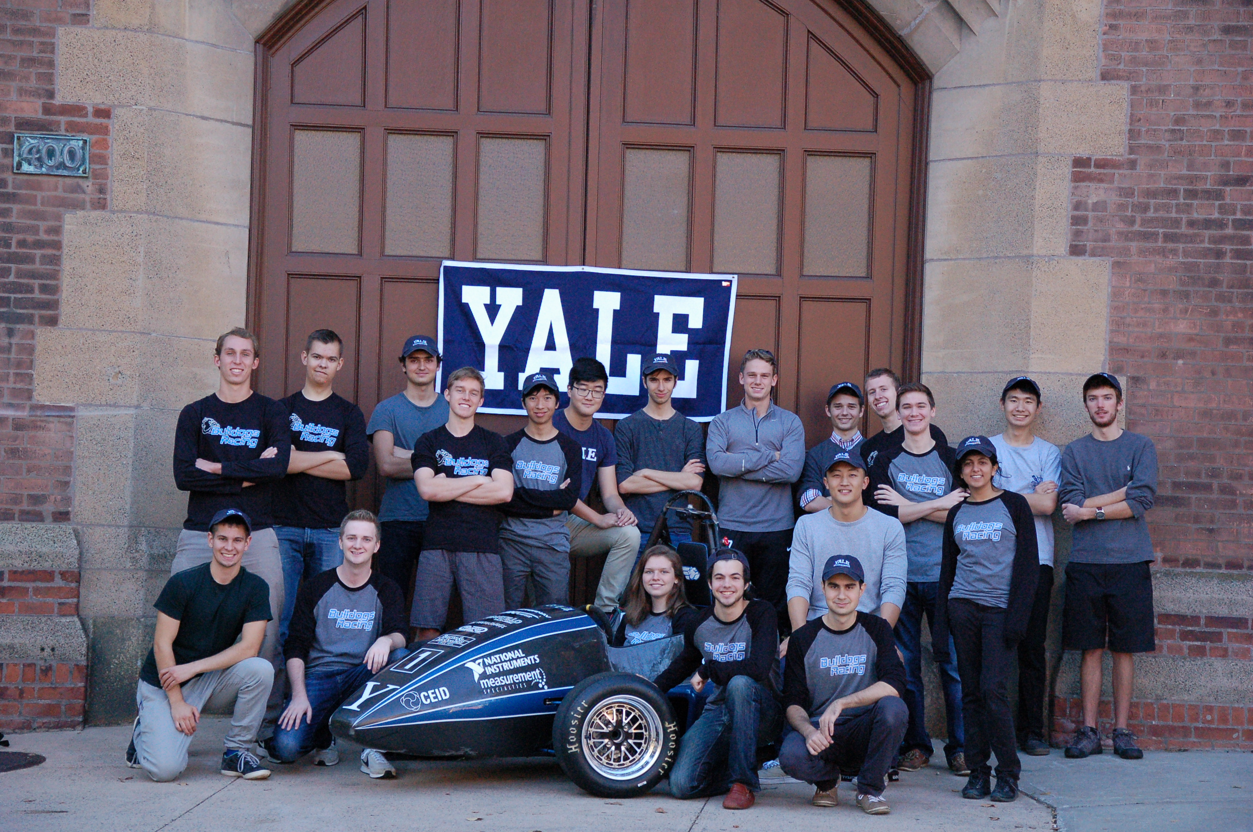

|  |  |
| --- | --- |
| University Name: | Yale University |
| Team Name: | Bulldogs Racing |
| Car Number: | 213 |

Main Team Contact for ESF related questions:

|  |  |
| --- | --- |
| Name: | Philip Piper |
| e-mail: | philip.piper@yale.edu |

# Vehicle Overview

Check the appropriate boxes:

**Vehicle is**

New (built on an entirely new frame)

New, but built on a pre-existing frame (FSAE, FS, FH electric-only, etc.)

Updated from a previous year vehicle

**Architecture**

Hybrid

Series

Parallel

Hybrid in Progress (HIP)

Electric-only

**Drive**

Front wheel

Rear wheel

All-wheel

**Regenerative braking**

Front wheels

Rear wheels

All wheels

None

# Frame and Body

List the materials used and the construction methodology for the frame and body. Include CAD drawings, photos or sketches as appropriate.

**Frame**

Materials

The space frame is made completely from AISI 4130 steel.

Joining Methods and Construction

Frame manufacturing was outsourced due to the inexperience of the team with tube fishmouthing, bending, and jigging. The team will be welding auxiliary mounting tabs that were not designed by the time that the frame work order was submitted (7/15).

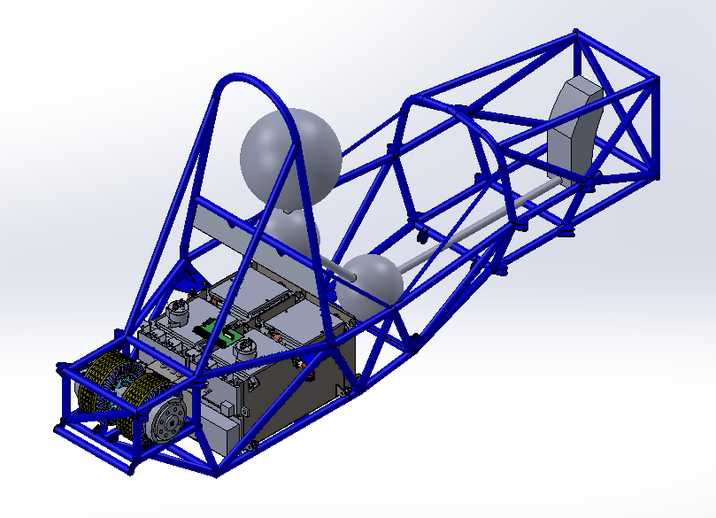

**Body**

Materials

2.97oz Dacron fabric will be used to cover the frame from the firewall to the front-most point of the front suspension mounting points. A carbon fiber nosecone will cover the top of the front roll hoop bracing and the sides of the nose forward of the front-most point of the front suspension mounting points. Note that the Dacron will be a permanent body whereas the nosecone will be removable.

Construction

The Dacron will be glued to the upper and lower members of the side impact structure, then shrunk via a heat gun. The carbon fiber nosecone will be constructed using a wet layup process over a foam plug.

# Engine

*Skip this section if electric-only*

## Engine Data

|  |  |
| --- | --- |
| Manufacturer |  |
| Model Number |  |
| Modified? (Per **IC1.1)** | Yes No |
| Number of Cylinders |  |
| Bore | mm |
| Stroke | mm |
| Displacement | liters |
| Fuel type | Gasoline E-85 Diesel |
| Max. Power | kW @ RPM |
| Max. Torque | N⋅m @ RPM |
| Weight (Approximate) | kg |

Table 1 - Engine Data

## Architecture

Describe how the outputs from the I.C. engine and electric drive systems are merged:

# Electrical System Overview

## Block Diagram

Figure 1 – include an electrical system block diagram showing all major parts associated with the tractive-system. (Not detailed wiring).

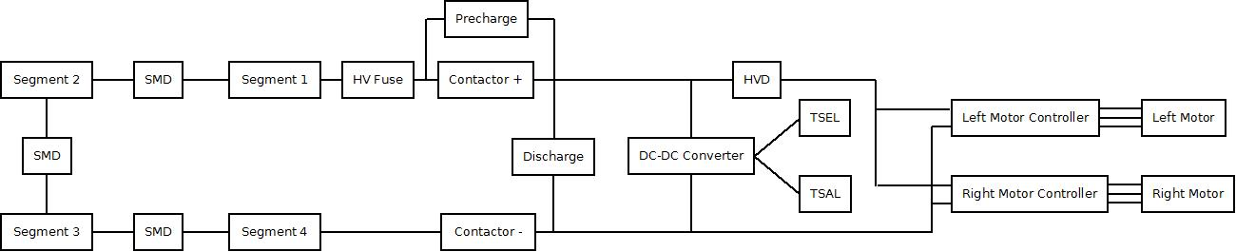

Figure 1- Electrical System Block Diagram

## Vehicle Layout

Figure 2 – include a diagram showing the location of all major parts associated with the tractive-system superimposed on a top view of the vehicle.

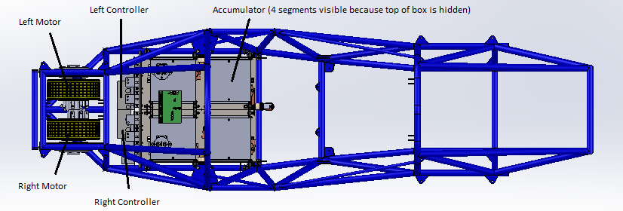

Figure 2 - Locations of major TS components

## Electrical System Parameters

Fill out the following table:

|  |  |
| --- | --- |
| Nominal Tractive System Voltage (TSV) | 283.8 VDC |
| Max. TSV (typically this is during charging) | 300 VDC |
| Control System voltage (GLV) | 12 VDC |
| Total Accumulator capacity | 4540.8 Wh |
| Accumulator type (Lead-acid, Li-Ion, NiMH, Ultracap…) | Li-Ion (LiFePO4) |
| Number of electric motors. (Total) | 2 |
| Are wheel motors used? | Yes No |

Table 2 - General Electrical System Parameters

## Firewall(s)

**Description/materials**

Describe the concept, layer structure and the materials used for the firewalls.

The firewall will be constructed to satisfy both Formula Hybrid and Formula SAE rules. Formula Hybrid requires a firewall made of 1.5mm aluminum while Formula SAE requires a firewall with at least a 0.5mm layer of aluminum and a second layer of UL94-V0 electrically insulating material. The firewall will be constructed of 1.5mm aluminum facing the tractive system side and either a 3mil Kapton tape layer, or a 1/8” thick Neoprene/EPDM/SBR foam layer facing the driver side.

**Position in car**

Provide CAD-rendering or sketches showing the planned location of the firewall(s).

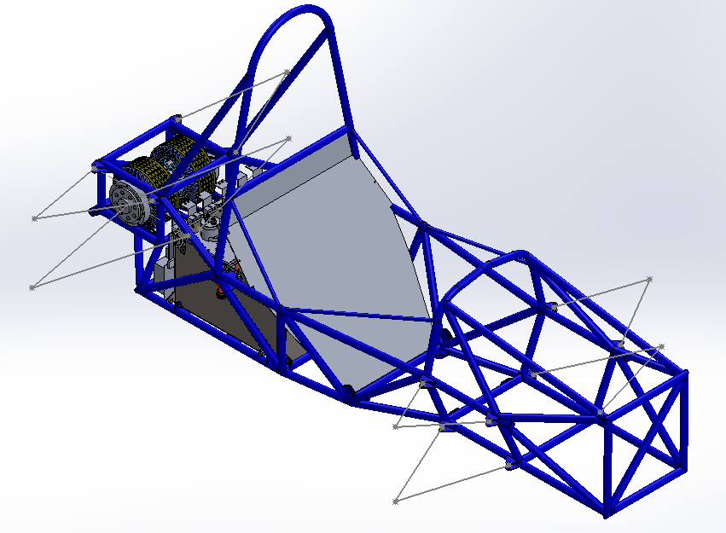

# Tractive System

## Motor(s)

Add additional tables if multiple motor types are used

|  |  |
| --- | --- |
| Manufacturer | Enstroj |
| Model Number | Emrax 207 Medium Voltage |
| Motor Type (PM, Induction, DC Brush…) | Permanent Magnet Asynchronous Axial Flux |
| Number of motors of this type used | 2 |
| Nominal motor voltage (Vrms l-l or Vdc) | 300 Vdc |
| Nominal / Peak motor current (A or A/phase) | Nom: 160 A Peak: 320 A |
| Nominal / Peak motor power | Nom: 25-40 kW Peak: 80 kW |

Table 3 - Motor Specifications

## Motor Controller

|  |  |
| --- | --- |
| Manufacturer | Unitek |
| Model Number | Bamocar D3 400-400 |
| Number of controllers of this type used: | 2 |
| Maximum Input voltage: | 400 V |
| Nominal Input Current: | 200 A |
| Output voltage (Vac l-l or Vdc) | 360 Vac |
| Isolation voltage rating between GLV and TS connections | Not listed. Specifies galvanic isolation between power and auxiliary voltage |
| Is motor controller accelerator input isolated from TSV? | Yes No |

Table 4 - Motor Controller Specifications

# Accumulator System

## Accumulator Pack

Provide a narrative design of the accumulator system and complete the following tables.

Note: Teams using ultracapacitor-based accumulators should request the "ESF Ultracap Addendum" and can leave the remainder of this section blank.

The accumulator system was designed using high density LiFePO4 pouch cells in four accumulator segments. These segments are each a stack of pouch cells that are compressed together using aluminum end plates and threaded rods. A plastic tab cover aligns and covers the tabs, which are bolted together between cells. 20Ah cells are used such that every cell in the pack is in series.

|  |  |
| --- | --- |
| Maximum Voltage (during charging): | 300 VDC |
| Nominal Voltage: | 283.8 VDC |
| Total number of cells: | 86 |
| Cell arrangement | Series Parallel |
| Are packs commercially or team constructed? | Commercial Team |
| Total Capacity: | 4.5408 kWh |
| Maximum Segment Capacity: | 4181.76 MJ |

Table 5 - Main Accumulator Parameters

## Cell Description

|  |  |
| --- | --- |
| Cell Manufacturer | A123 |
| Model Number | Amp20M1HD-A |
| Cell type (prismatic, cylindrical, pouch, etc.) | Pouch |
| Are these pouch cells | Yes No |
| Cell nominal capacity: | 20 Ah |
| Discharge rate for nominal capacity (e.g. 1C, 2C etc.) | 2C |
| Maximum Voltage: | 3.6 V |
| Nominal Voltage: | 3.3 V |
| Minimum Voltage: | 2.0 V |
| Maximum Cell Temperature (charging) | 60 °C |
| Maximum Cell Temperature (discharging) | 60 °C |
| Cell chemistry: | LiFePO4 |

Table 6 - Main Cell Specification

## Cell Configuration

Describe configuration: e.g., *N* cells in parallel then *M* packs in series, or *N* cells in series then *M* strings in series.

86 cells in series.

## Lithium-Ion Pouch Cells

The vehicle accumulator DOES / DOES NOT use individual pouch cells. (Check one)

*Note: Designing an accumulator system utilizing pouch cells is a substantial engineering undertaking which may be avoided by using prismatic or cylindrical cells.*

If your team has designed your accumulator system using individual Lithium-Ion pouch cells, include drawings and calculations demonstrating compliance with all sections of rule **EV3.9**. If your system has been issued a variance to **EV3.9** by the Formula Hybrid rules committee, include the required documentation from the cell manufacturer.

EV3.9.1 – Pouches are arranged in two 22 and two 21 cell face-to-face stacks.

EV3.9.2 – Aluminum end plates and four aluminum threaded rods mechanically restrain the stack in one axis to a set length. Foam filler compresses as the cells expand to keep the cell face pressure within 4 to 18 psi, as suggested by the manufacturer A123. Distorted thread lock nuts are used to meet the temperature requirement of EV3.9.2(a) and EV3.9.2(c). A123 states that the cells will expand by 1% during regular cycling, and 3-5% during the cell’s lifetime. The stack length set point is determined on the last line in the “Avg stack thickness (mm)” column. Note that the filler is chosen such that the “Total cell expansion (mm)” is less than the “Total filler expansion (mm)”.

|  |  |  |  |  |
| --- | --- | --- | --- | --- |
| **Even Stack** |  |  | **Odd Stack** |  |
| Cells |  |  | Cells |  |
| Number of cells | 22 |  | Number of cells | 21 |
| Cell thickness (mm) | 7.1 |  | Cell thickness (mm) | 7.1 |
| Min cell expansion (%) | 1 |  | Min cell expansion (%) | 1 |
| Max cell expansion (%) | 6 |  | Max cell expansion (%) | 6 |
| Min cells thickness (mm) | 157.762 |  | Min cells thickness (mm) | 150.591 |
| Max cells thickness (mm) | 165.572 |  | Max cells thickness (mm) | 158.046 |
| Total cell expansion (mm) | 7.81 |  | Total cell expansion (mm) | 7.455 |
|  |  |  |  |  |
| Heat Spreaders |  |  | Heat Spreaders |  |
| Number of heat spreaders | 12 |  | Number of heat spreaders | 11 |
| Heat spreader thickness (mm) | 0.508 |  | Heat spreader thickness (mm) | 0.508 |
| Total thickness (mm) | 6.096 |  | Total thickness (mm) | 5.588 |
|  |  |  |  |  |
| Kapton Tape |  |  | Kapton Tape |  |
| Number of Kapton tapes | 24 |  | Number of Kapton tapes | 22 |
| Kapton tape thickness (mm) | 0.0762 |  | Kapton tape thickness (mm) | 0.0762 |
| Total thickness (mm) | 1.8288 |  | Total thickness (mm) | 1.6764 |
|  |  |  |  |  |
| End Plate |  |  | End Plate |  |
| Number of end plates | 2 |  | Number of end plates | 2 |
| End plate thickness (mm) | 6.35 |  | End plate thickness (mm) | 6.35 |
| Total thickness (mm) | 12.7 |  | Total thickness (mm) | 12.7 |
|  |  |  |  |  |
| Filler |  |  | Filler |  |
| Number of fillers | 10 |  | Number of fillers | 9 |
| Filler thickness (mm) | 1.5875 |  | Filler thickness (mm) | 1.5875 |
| 4psi expansion (%) | 0 |  | 4psi expansion (%) | 0 |
| 18psi expansion (%) | 55 |  | 18psi expansion (%) | 55 |
| Min filler thickness (mm) | 15.875 |  | Min filler thickness (mm) | 14.2875 |
| Max filler thickness (mm) | 24.60625 |  | Max filler thickness (mm) | 22.14563 |
| Total filler expansion (mm) | 8.73125 |  | Total filler expansion (mm) | 7.858125 |
|  |  |  |  |  |
| Stack |  |  | Stack |  |
| Min stack thickness (mm) | 194.2618 |  | Min stack thickness (mm) | 184.8429 |
| Max stack thickness (mm) | 212.3906 |  | Max stack thickness (mm) | 201.7435 |
| Avg stack thickness (mm) | 203.3262 |  | Avg stack thickness (mm) | 193.2932 |

EV3.9.3 – Poron 4701-40 is used as filler between every other cell. 20mil thick aluminum heat spreaders are used in the other half of the cell-cell interfaces. Kapton tape is used to insulate the cells from the aluminum heat spreaders.

EV3.9.4 – Cell tab connections are completely enclosed in a 3D printed, two piece, high temperature plastic enclosure. #6-32 distorted thread lock nuts along with two aluminum load spreaders are used to sandwich two adjacent tabs together. The aluminum load spreaders, nuts, and socket head bolts are insulated by the plastic tab cover.

EV3.9.5 – A repeating frame of weather-resistant neoprene/EPDM/SBR foam outlines the main body of the cell, holding it in place during manufacturing of the stacks. The aluminum threaded rods run through the repeating frame to fix the frame, and therefore the cells in place with respect to each other.

EV3.9.6 – Stacks are firmly anchored to the accumulator enclosure at three points on each aluminum end plate with ¼” bolts and nylon lock nuts.

## Accumulator Management System (AMS)

|  |  |
| --- | --- |
| AMS Manufacturer | eLithion |
| Model Number | Lithiumate Pro |
| Number of AMSs | 1 |
| Upper Cell Voltage Trip | 3.485 V |
| Lower Cell Voltage Trip | 2.0 V |
| Temperature Trip | 60 °C |

Table 7 - AMS Data

## Charging

We are still working on trying to get one of the following chargers: Brusa NLG513, Manzita Micro PFC20X, or Current Ways BC-Series. Below is our fallback option from Elcon.

|  |  |
| --- | --- |
| Charger Manufacturer | Elcon |
| Model Number | PFC 4000 TCCH-288-12 |
| Maximum Charging Power: | 4 kW |
| GLV/TS isolation location:  (i.e. cell boards, main unit, etc.) | Main unit |
| UL Certification? | Yes No |
| Maximum Charging Voltage: | 389 V |
| Maximum Charging Current: | 6 A at 115 VAC |
| Input Voltage: | 115 VAC single phase |
| Input Current: | Not rated; 93% efficiency |

Table 8 - Accumulator Charging Data

## Accumulator Container/Housing

Describe the design of the accumulator container. Include the housing material specifications and construction methods.

The accumulator was designed to conform to Formula SAE rule EV3.4. This means that the floor of the accumulator is made of 0.049” steel, the walls are made of 0.035” steel, and internal walls of 0.035” steel separate the segments. Additionally segment fasteners are ¼” Grade 5 with nylon lock nuts. Protocase has offered to cut the steel pieces, namely the floor, outside wall, and two internal wall pieces that fit together. The outer wall piece will be bent at Yale using a sheet metal brake, then the pieces will be welded together.

Where will the accumulators be located?

The accumulator will be located behind the firewall and in front of the motors. See section 4.2.

Will you be taking advantage of the virtual accumulator housing rule? (**EV3.3**)

No

## Shutdown Circuit

Include a schematic of the shutdown circuit for your vehicle including all major components in the loop.

***Note:*** *The design of the shutdown circuit and team members understanding of how it works is extremely important. Take the time to be sure it is right.*

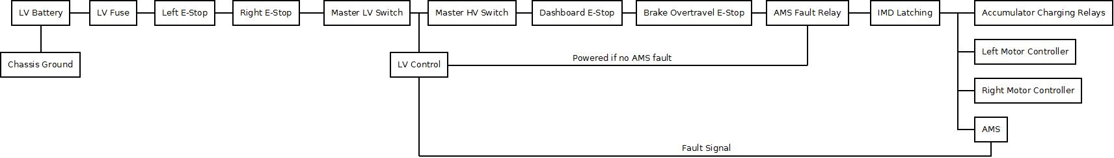

Figure 3 – Safety Shutdown Circuit Schematic

## IMD

Describe the IMD used and complete the following table:

|  |  |
| --- | --- |
| Manufacturer | Bender |
| Model Number | IR155-3204 |
| Set response value: | 100 kΩ  (333 Ω/Volt) |

Table 9 - Parameters of the IMD

# GLV System

## GLV System Data

Provide a brief description of the GLV system and complete the following table.

The GLV system is composed of the power, shutdown, insulation monitoring device, brake system plausibility, inertia switch, power distribution, ground bus, pedal box, control, accumulator control, dashboard, and indicator subsystems. Each of these subsystems fulfill a section of the Formula Hybrid or Formula SAE rules.

|  |  |
| --- | --- |
| GLV System Voltage | 12 V |
| GLV Main Fuse Rating | 20 A |
| GLV Accumulator type | Lead acid or Li-ion |
| How is the GLV storage recharged? | We will remove it and use a charger |

Table 10 - GLV Data